**Name:** Devansh Shah

**Branch/Batch:** TY-IT/A4

**Roll No:** 1914078

**UI-UX IA-1 IN CLASS ASSIGNMENT-4**

**Task:** Conduct Systematic Heuristic Evaluation on ant two websites referring to any heuristics (i.e., Neilson's Principles). Refer PPT for module 5.2 for the same. Add implications after evaluation.

**Solutions:**

I conducted a heuristic evaluation of two popular travel planning websites: Air India and Expedia.

A heuristic evaluation is an inspection method in which you systematically apply heuristics (qualitative guidelines) to find and explain problems.

I applied **Jakob Nielsen’s heuristics:**

∙ Visibility of system status

∙ Match between system and the real world

∙ User control and freedom

∙ Consistency and standards

∙ Error prevention

∙ Recognition rather than recall

∙ Flexibility and efficiency of use

∙ Aesthetic and minimalist design

∙ Help users recognize, diagnose, and recover from errors

∙ Help and documentation

My goal was to apply Nielsen’s heuristics to critique the user interface designs of both websites by performing detailed heuristic evaluations.

I’d like to share these evaluations as a way to illustrate how to apply this UX method. **Design Brief**

The task was to compare the process of buying a one way ticket on two different websites. I could pick any mode of transit I liked. And I had to try purchasing a one way ticket from my home city to any destination that I liked.

I had to start on the homepage and work my way through the task, while keeping a list of the heuristics handy. As I discovered usability problems with the sites, I made sure to write them down and take a screenshot.

Once I had finalized the list of violations, I gave a severity rating to each. I used this severity rating scale:

**0 — don’t agree that this is a usability problem**

**1 — cosmetic problem**

**2 — minor usability problem**

**3 — major usability problem; important to fix**

**4 — usability catastrophe; imperative to fix**

**Name:** Devansh Shah **Branch/Batch:** TY-IT/A4 **Roll No:** 1914078

I was to summarize the task I was trying to accomplish, show a screenshot where the violation occurred, list the heuristic violated, and describe the violation and its severity.

**1. Air India**

**Website Link: https://www.airindia.in/**

**Task:** Purchasing a one-way flight from Mumbai, India to Delhi, India departing on 11 May 2022.

**First Issue/Violation**: It was difficult to find out information about the categories- ‘Super Value’, ‘Flexi saver’, ‘Flexible’.

**Severity:** 2

**Heuristics violated:** Help and Documentation

**Description/Implication:** When I click on “Search Flight” on the homepage after entering information about the Departure location ,Arrival location, date of journey and number of passengers, I get redirected to this page where all the information related to the available flights on a particular date get displayed. Along with this information three ticket categories Super value, Flexi Saver and Flexible are visible with different ticket prices for each. However, it is really difficult for the user to differentiate between the three categories just on the basis of price. Other information related to difference in baggage allowance, in-flight services etc. would have been more helpful for the user to make a choice. Currently, there is no button/dropdown available to show any information concerning this.

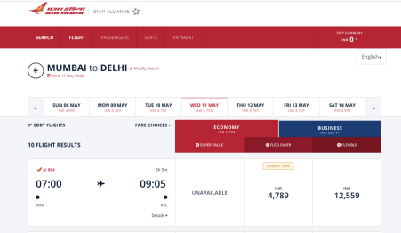

**Second Issue/Violation**: It was difficult to find out information about the total time(hours) of layover and terminal information of each stop in case of One-stop flights

**Severity:** 3

**Heuristics violated:** Recognition rather than recall, Help and Documentation

**Description/Implication:** In case of booking one-stop flights there is no enough information regarding the time one may need to spend in case of layover ( Although this task can be done using simple mathematical calculation, but for a person with no mathematical calibre, this task becomes difficult and is not appropriate from UI point of view). Also, information regarding terminal where the flight arrives is not available, which would have been helpful for the users to arrange for pickup and drop upon their arrival in the desired location.

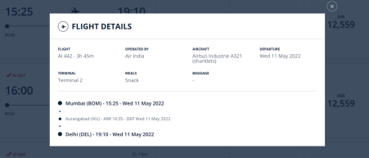

**Third Issue/Violation**: It was difficult to find out where the error has actually occurred. **Severity:** 4

**Heuristics violated:** Help users recognize, diagnose, and recover from errors

**Description/Implication:** After selecting the desired flight, as I click on “Passenger Details” to proceed to next step, I am not getting redirected to the new page and there is no information available regarding any error either in the form of an alert( Dialogue box) or any warning on the current part of the screen(can be seen in the first screenshot).Only when I scroll up and see that I haven’t checked the checkboxes in the “Insurance” section( can be seen in the second screenshot), I get to know of the error, which was a really cumbersome task. It would have been helpful if the user gets redirected to the section where an error has occurred or all the errors were available in the form of alert box/ warnings.

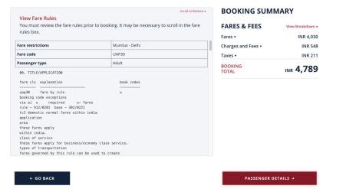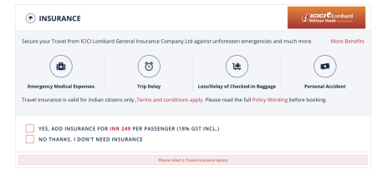

**Fourth Issue/Violation**: Option to sort the flights based on a particular price range ,time and connection unavailable.

**Severity:** 2

**Heuristics violated:** Flexibility and efficiency of use

**Description/Implication:** When I click on “Sort Flights” the only options available to me are to sort the flights from “low” to “high” and “high” to “low” based on connections, time and price. It would have been helpful if more clear options to sort the flights were available and users themselves could specify the price range ( e.g. 3000-8000) ,time( e.g.11am-1pm) and connection ( e.g. via Jaipur) rather than sorting only on the basis of low to high. This

makes the UI inflexible and is therefore, very inefficient to use.

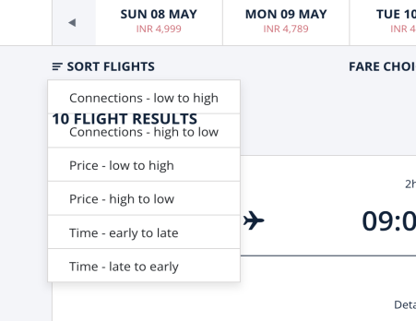**2. Expedia**

**Website Link: https://www.expedia.co.in/**

**Task:** Purchasing a one way flight from Mumbai to Delhi departing on 11 May 2022. **First Issue/Violation**: It was difficult to find out information about “bag fees.” **Severity:** 3

**Heuristics violated:** Recognition and Help

**Description/Implication:** When I click on “More info” under “Bag fees” another tab opens and shows me this information:

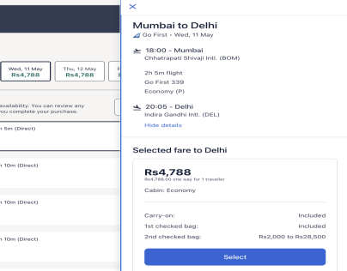

Here it would have been helpful to see the following info highlighted (instead of being part of the paragraph):

**If your trip includes more than one airline, baggage fees are generally determined by the first carrier on the ticket.**

I’d also have wanted to have some other link where I can go check for more info, since they say “generally” and I wanted to make sure how much I would end up paying in fees. In order to find that information, I clicked on “more info” inside “bag fees” and a window opened saying: “If your trip includes more than one airline, baggage fees are generally determined by the first carrier on the ticket.” It should not take this long to get this vitally important information regarding fees.

**Second Issue/Violation**: Suggestions and info needed to help user choose which seat they prefer.

**Severity:** 2

**Heuristics violated:** User control and freedom, Help

**Description/Implication:** It would have been nice to have some suggestions being offered to help me choose from the seats available. For example, they can ask whether I have any need to walk often to stretch in which case an aisle seat might be better. Or I could be reminded of the responsibilities that passengers seating by the exit rows have.

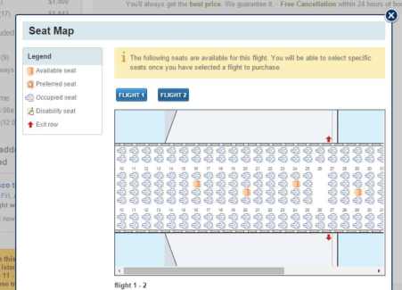**Third Issue/Violation**: Insufficient information regarding their flight rating system. **Severity:** 2

**Heuristics violated:** Consistency and Standard, Help and Documentation

**Description/Implication:** : I noticed that my flight was rated as “Satisfactory Flight (6.7 out of 10).” I clicked to find out what they meant by that. There was some information offered, but it was too generic and not enough. I was left wondering which of the factors mentioned in the pop-up description lowered this flight’s score. This could be fixed by adding a “more info” link at the end of the description for users who want to find out more.

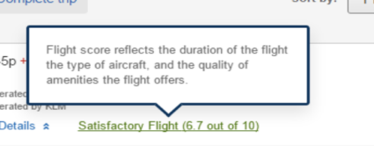

**Fourth Issue/Violation**: Confusion about their “Free Cancellation within 24 Hours” policy. **Severity:** 4

**Heuristics violated:** Error prevention, Recognition rather than recall

**Description/Implication:** : I clicked on “Show Flight Details” and I saw a message that said there was “Free Cancellation” within 24 hours of booking. This was interesting considering that I didn’t click on the “refundable” option at the beginning. It would be a good idea to show this info prominently at the beginning or even on the main page if that’s their overall policy. I could have just left to another website after seeing that their main page shows “refundable” as an option, which implies that the default is that flights are non-refundable.

